 **Mitchell Half Boards Advertising **

MMH is offering advertising on their new half boards. MMH will be selling advertising on each of the seven 95 inch sections. Each 95 inch section is double sided so advertising can be bought on one or both sides. The advertising will remain as long as the boards last (10 to 20 years expected life). Any major damage to advertising will be fixed by MMH for the first 4 years.

**The cost for one 95 inch section with advertising on both sides is $1,775**

**The cost for one 95 inch section with advertising on one side is $980**

Pricing includes the prorated cost of the boards plus the cost of the advertising. The advertising cost includes the following:

꙳ 32”x92” digital printed full colour graphics installed and laminated for extra protection

꙳ a small amount sign set time for each panel.

꙳ Logos not in Snyders Graphics’ system must be emailed to Snyders Graphics as a high resolution usable digital file.

꙳ Custom logo design if required is charged at a rate of $80 / hr separately by Snyders Graphics

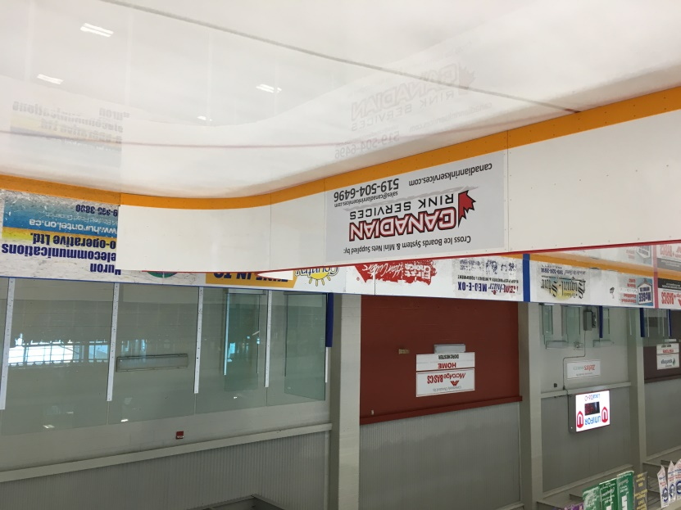

If interested please contact any of the MMH Hockey Executive or Email executive@mitchellminorhockey.com